**Security in the crypto world: That's what you need to know**

The crypto market is still relatively young and if you invest now you are still one of the early adopters. New markets also always give rise to fraudsters, also increasingly in the crypto sector.

Here are our tips on how to protect yourself:

1. Do not use free WiFi
2. Secure passwords:
   1. No passwords that are easy to guess, preferably with upper and lower case letters, numbers and special characters
   2. change your passwords regularly
   3. do not use the same passwords on all platforms
3. Only buy cryptocurrencies and NTFS on reputable exchanges. The size of the exchange is a good indicator here
4. Turn on your 2-factor authentication as additional security to the password
5. Get a cold wallet for larger amounts and valuable NFTs
6. Have multiple crypto accounts and spread your investments
7. Check the address to which you send cryptocurrencies and the blockchain network (see Fig. 1 and 2) through which you process the transaction several times. If either of them contain errors, your money will be lost. It doesn't show up in your account.
8. Do not save SeedPhrase online, do not tell anyone, keep it in a safe place
9. Do not open links and connect your account to websites that you do not know. Before you connect your Metamask or other wallet to a site, triple check that it is really the right address. Often only letters or the ending are changed. Scammers are very resourceful here. Pay attention.

Abb. 1: Choose correct network

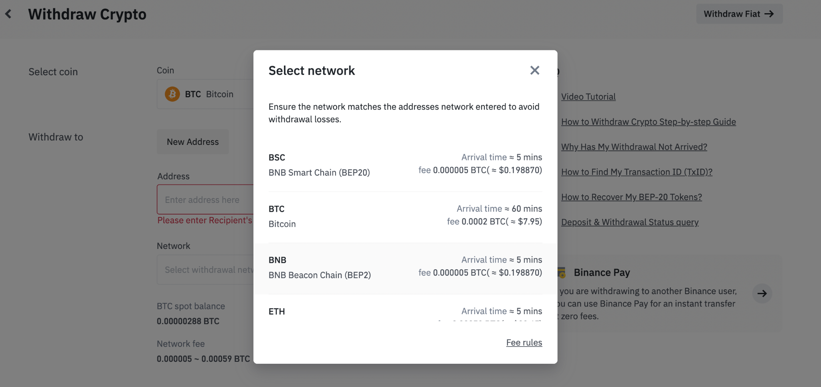

Abb. 2: Pay attention to copy/past the correct adress

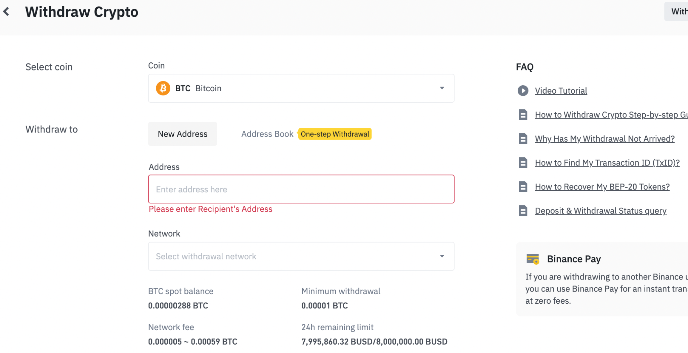

If you use these tips, you can reduce your risk.